(Approx. 1394 words)
OFFLINE MAPS FOR PORTABLE DEVICES
You can download free offline maps for later use on the go where no cell tower is accessible
Part 1 of a 3-part article series
By John Krout, Presenter & Newsletter Contributor
Potomac Area Technology and Computer Society
https://www.patacs.org
jkrout.apcug.presenter (at) gmail.com

INTRODUCTION

Mapping apps on portable devices require two data sources: (1) maps and (2) GPS signals. The standard default maps for widely used apps such as Google Maps and Waze are delivered to portable devices on-demand over cell phone data networks, meaning cell towers.

This access method for maps is not feasible in regions where a cell tower is absent. There are many such regions in the US. I have found myself beyond the reach of cell towers in much of the Potomac Highlands of West Virginia and Maryland and other mountainous areas nationwide, including most of Yellowstone National Park. Mountain ridges in these regions lack sufficient cell towers to make data service available in many areas. One or more ridges often block the line of sight to nearby towers.

The towers are intentionally limited to the Yellowstone Villages in Yellowstone, meaning the clusters of hotels, restaurants, gift shops, and gas stations around that gigantic park. When I visited that park in early September 2018, I found that data service during day times around Old Faithful Village was slowed to a crawl by the crowd of tourists posting photos and videos to social media.

You can count on GPS service just about anywhere outdoors since the GPS signals are delivered by satellites. Car GPS receivers have maps built-in, so those work where cell sites are too distant. But map apps cannot display online maps where cell towers are a distant memory.

I decided to look into how some mapping apps can use offline vector maps. Offline means maps stored on your Android device. Vector means that the maps show sharp detail over a wide zoom range, from one block to several miles, just like your favorite mapping app does.

While using an offline map, your map app will work fine where cell towers are absent or just plain slow.

TYPES OF MAP APPS

I came across three types of map apps that use offline maps. There may be other types, but these three describe the nine or ten map apps I have used over the past several years.

HYBRID: These apps provide online maps and can use offline maps installed by the user. Examples include Locus Map, a full-featured mapping app, and c:geo, a geocaching-oriented app in which a map display geocache icons. Unfortunately, both are available only for Android phones and tablets.

OFFLINE ONLY: These apps only provide offline maps; the maps must be downloaded using the app itself. This type has been mushrooming on app stores as of April 2021. Examples include Maps.me, Alltrails, and Avenza maps, available for both Android and iOS phones and tablets.

ONLINE+: These apps provide online maps with the option to download map portions for offline use. An example is Google Maps, available for both Android and iOS phones and tablets.

For those last two types, a caution is worth noting for any reader whose cell phone contract includes a monthly limit on data usage. Maps are big; downloading maps while connected only to a cell tower can use up your cell phone service contract monthly data limit in a hurry. If you have such a contract and know where you will be traveling, download offline maps in advance while connected to Wi-Fi.

This article series will explain how to configure and use offline maps in Locus Map (Hybrid type) and Google Maps (Online+ type).

OFFLINE MAP TRADEOFFS

Before you dive in, you should know there are some tradeoffs associated with offline maps. Mostly the news is good.

Whether or not you are in range of a cell tower, offline maps use much less battery power than online maps because your device is not constantly asking for more map data from cell towers.

If your cell phone contract includes a ceiling on monthly data usage, then using offline maps will help you stay below the data usage ceiling.

The offline maps I use are for Hybrid-type apps are big files, as you will see below. Fortunately, the maps can be stored on an inexpensive microSD card on your Android device.

FINDING OFFLINE MAPS TO DOWNLOAD

MapsForge is a German website that provides freely downloadable vector maps of the world, divided into various parts. For the US, you can download maps of individual states or multi-state regions. In addition, you can download maps of Canadian provinces and maps of most countries around the world. The US maps display place names in English. All of the Mapsforge maps are vector maps.
Ultimately the maps for North America can be downloaded from the German university site below, which is a fast university mirror site for Mapsforge:

http://ftp-stud.hs-esslingen.de/pub/Mirrors/download.mapsforge.org/maps/v5/north-america/

That web page is shown in Illustration 1. Each map file name ends with the extension map. The easiest way to get maps for the entire US is to download the five files beginning with the US, shown within the red outline.
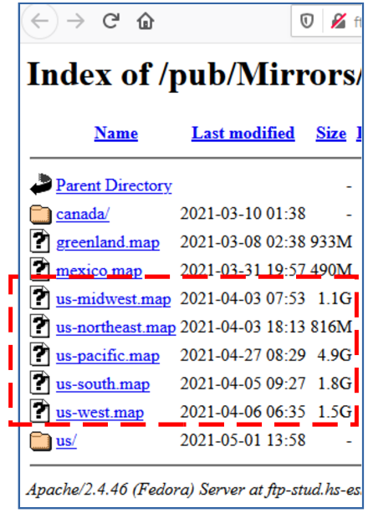
US STATED COVERED BY THE MAPSFORGE REGIONAL FILES

US-South: DE, MD, VA, WV, NC, SC, GA, FL, AL, MS, LA, TX, OK, AR, TN, KY
US-Northeast: PA, NY, NJ, CT, RI, MA, VT, NH, ME
US-Midwest: ND, SD, NE, KS, MN, IA, MI, MO, OH, WI, IL, IN
US-West: WA, OR, CA, NV, AZ, CO, NM, UT, ID, MT, WY
US-Pacific: AK, HI
Illustration 1
Additionally, the website folder named US contains a map for each US state at the bottom of the illustration. To get maps for the entire US from that directory, you would have to do 50 downloads rather than just downloading five regional maps. On the other hand, if you need maps for only a few US states, consider downloading one regional map or perhaps a couple of state maps.

The directory named Canada includes a map for each province of Canada.

The mirror site is a File Transfer Protocol (FTP) site. All the links to map files are FTP links, which means your click on a map file name in the website folder causes your web browser to download the file.

Three US regional files are 1 GB or larger, so the downloads are not accomplished quickly, even with my ISP's 300+ megabits per second (Mbps) download speed. The largest took about 6 minutes to download. If your download speed is minimal, or you have only minimal space on your Android device to save offline maps, you may prefer to download a few state maps instead.

You may notice that the US-Pacific.map file is significantly larger than any other. It is also seven times larger than its predecessor map, which was posted online in July 2020. I asked Mapsforge if they knew of any reason for that change. Unfortunately, as of May 2021, they have yet to find one. Perhaps, by the time you see this article, that problem will have been resolved by Mapsforge, and you will find a later, more compact US-Pacific.map file on the website. If not, and you need to use an offline map for Hawaii or Alaska, I suggest downloading the state map file found in the US folder on the site. The Alaska.map file, though quite large, is far smaller than the US-Pacific.map file.

DOWNLOAD STRAIGHT TO PHONE OR TO COMPUTER?

I downloaded it to my personal computer because it is connected to my router by ethernet. Thus, it generally has far higher speed service than my phone, connected to my router by Wi-Fi. Also, by keeping the maps files on my computer, I can readily install them on my tablet, retired phones, and so forth.

This ends Part 1 of this article series. In part 2, you will learn how to use these Mapsforge offline maps in the Locus Map app.

ABOUT THE AUTHOR: John Krout has been writing about the uses of personal computers since the early 1980s and is a frequent contributor to PATACS Posts, the newsletter of the Potomac Area Technology and Computer Society. He also occasionally demonstrates interesting uses of personal computers or smartphones at PATACS meetings. As of the end of 2019, before the pandemic started, his travels have included 48 US states, Europe, and South America.

